1. **Top 20 zip codes by total transaction value**

SELECT BRANCH_ZIP, SUM(TRANSACTION_VALUE) AS TOTAL

FROM CDW_SAPP_D_BRANCH

JOIN CDW_SAPP_F_CREDIT_CARD ON (CDW_SAPP_D_BRANCH.BRANCH_CODE = CDW_SAPP_F_CREDIT_CARD.BRANCH_CODE)

GROUP BY BRANCH_ZIP

ORDER BY TOTAL DESC LIMIT 20;

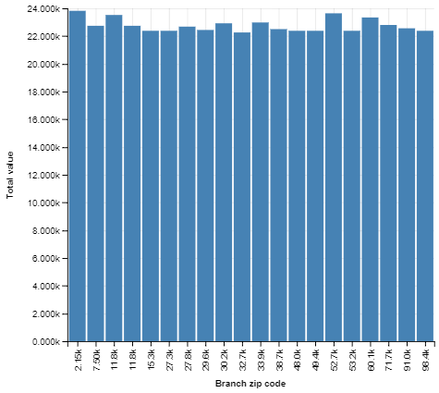

1. **Total transaction value for each transaction type by quarter in 2018**

SELECT TRANSACTION_TYPE, SUM(TRANSACTION_VALUE) AS TOTAL, QUARTER

FROM CDW_SAPP_F_CREDIT_CARD JOIN CDW_SAPP_D_TIME ON (CDW_SAPP_D_TIME.TIMEID = CDW_SAPP_F_CREDIT_CARD.TIMEID)

WHERE YEAR = 2018

GROUP BY TRANSACTION_TYPE, QUARTER;

